**1. Design an application that contains Phone Contacts in vertical linear manner. Selected contact appears at the top of the list with a large italicized font and a blue background.**

**AndroidManifest.xml:**

*<?*xml version="1.0" encoding="utf-8"*?>*<manifest xmlns:android="http://schemas.android.com/apk/res/android"  
 package="com.example.prgm1phonecall">  
 <uses-permission android:name="android.permission.CALL_PHONE"/>  
  
 <application  
 android:allowBackup="true"  
 android:icon="@mipmap/ic_launcher"  
 android:label="@string/app_name"  
 android:roundIcon="@mipmap/ic_launcher_round"  
 android:supportsRtl="true"  
 android:theme="@style/AppTheme">  
 <activity android:name=".MainActivity">  
 <intent-filter>  
 <action android:name="android.intent.action.MAIN" />  
  
 <category android:name="android.intent.category.LAUNCHER" />  
 </intent-filter>  
 </activity>  
 </application>  
</manifest>

**activity_main.xml:**

*<?*xml version="1.0" encoding="utf-8"*?>*<LinearLayout xmlns:android="http://schemas.android.com/apk/res/android"  
 xmlns:app="http://schemas.android.com/apk/res-auto"  
 xmlns:tools="http://schemas.android.com/tools"  
 android:layout_width="match_parent"  
 android:layout_gravity="center_vertical"  
 android:orientation="vertical"  
 tools:context=".MainActivity"  
 android:layout_height="match_parent">  
 <Button  
 android:id="@+id/buttoncall"  
 android:layout_width="match_parent"  
 android:layout_height="wrap_content"  
 android:background="#2136f6"  
 android:text="call 0377778888"  
 android:textColor="#FFFFFF"/>  
  
</LinearLayout>

**MainActivity.java:**

package com.example.prgm1phonecall;  
import androidx.appcompat.app.AppCompatActivity;  
import androidx.core.app.ActivityCompat;  
import android.Manifest;  
import android.content.Intent;  
import android.content.pm.PackageManager;  
import android.net.Uri;  
import android.os.Build;  
import android.os.Bundle;  
import android.view.View;  
import android.widget.Button;  
  
public class MainActivity extends AppCompatActivity {  
private Button button;  
 @Override  
 protected void onCreate(Bundle savedInstanceState) {  
 super.onCreate(savedInstanceState);  
 setContentView(R.layout.*activity_main*);  
 button=(Button)findViewById(R.id.*buttoncall*);  
 button.setOnClickListener(new View.OnClickListener() {  
 @Override  
 public void onClick(View v) {  
 Intent callntent=new Intent(Intent.*ACTION_CALL*);  
 callntent.setData(Uri.*parse*("tel:0377778888"));  
 if(ActivityCompat.*checkSelfPermission*(MainActivity.this, Manifest.permission.*CALL_PHONE*)!= PackageManager.*PERMISSION_GRANTED*) {  
 return;  
 }  
 startActivity(callntent);  
 }  
 });  
 if(Build.VERSION.*SDK_INT* >= Build.VERSION_CODES.*M*)  
 ActivityCompat.*requestPermissions*(MainActivity.this,new String[]{Manifest.permission.*CALL_PHONE*},1);  
 }  
}

**Output:**

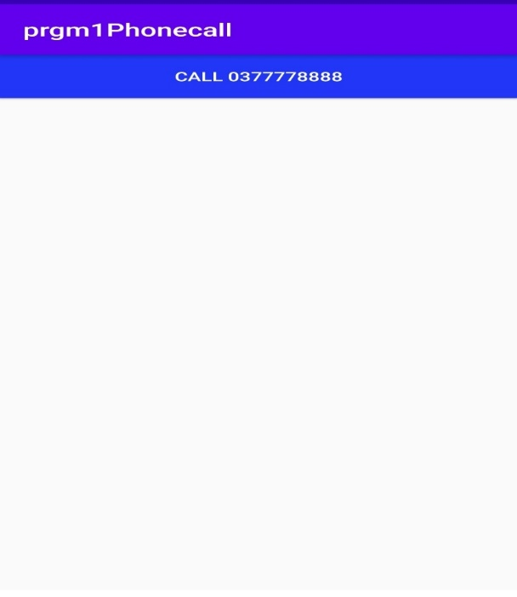

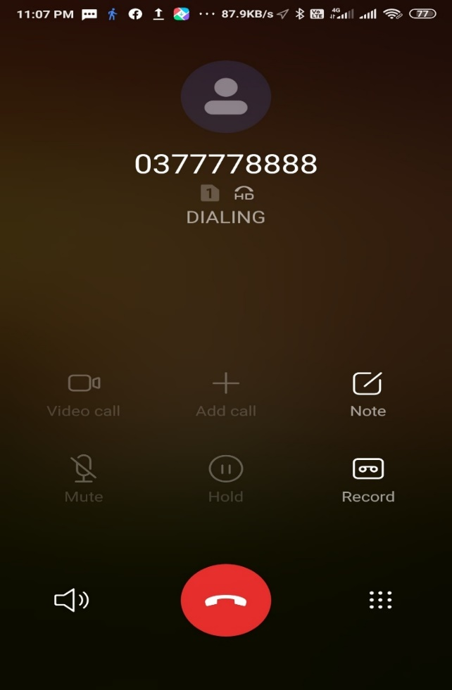

**2. Create an application that uses Layout Managers and Event Listeners**

**activity_main.xml:**

*<?*xml version="1.0" encoding="utf-8"*?>*<RelativeLayout xmlns:android="http://schemas.android.com/apk/res/android"  
 xmlns:app="http://schemas.android.com/apk/res-auto"  
 xmlns:tools="http://schemas.android.com/tools"  
 android:layout_width="match_parent"  
 android:layout_height="match_parent"  
 android:gravity="center"  
 tools:context=".MainActivity">  
  
  
 <LinearLayout  
 android:layout_width="match_parent"  
 android:layout_height="100dp">  
  
 <TextView  
 android:id="@+id/textView"  
 android:layout_width="match_parent"  
 android:layout_height="wrap_content"  
 android:layout_margin="30dp"  
 android:layout_weight="1"  
 android:gravity="center"  
 android:text="Detail form"  
 android:textSize="25sp" />  
 </LinearLayout>  
  
 <GridLayout  
 android:layout_width="match_parent"  
 android:layout_height="match_parent"  
 android:layout_marginTop="100dp"  
 android:layout_marginBottom="200dp"  
 android:columnCount="2"  
 android:rowCount="3">  
  
 <TextView  
 android:id="@+id/textView1"  
 android:layout_width="wrap_content"  
 android:layout_height="wrap_content"  
 android:layout_row="0"  
 android:layout_column="0"  
 android:layout_margin="10dp"  
 android:text="Name"  
 android:textSize="20sp" />

<EditText  
 android:id="@+id/editText"  
 android:layout_width="wrap_content"  
 android:layout_height="wrap_content"  
 android:layout_row="0"  
 android:layout_column="1"  
 android:layout_margin="10dp"  
 android:ems="10"  
 android:gravity="center"  
 android:inputType="text" />  
  
 <TextView  
 android:id="@+id/textView2"  
 android:layout_width="wrap_content"  
 android:layout_height="wrap_content"  
 android:layout_row="1"  
 android:layout_column="0"  
 android:layout_margin="10dp"  
 android:gravity="center"  
 android:text="Reg.No"  
 android:textSize="20sp" />  
  
 <EditText  
 android:id="@+id/editText2"  
 android:layout_width="wrap_content"  
 android:layout_height="wrap_content"  
 android:layout_row="1"  
 android:layout_column="1"  
 android:layout_margin="10dp"  
 android:ems="10"  
 android:inputType="number" />  
  
 <TextView  
 android:id="@+id/textView3"  
 android:layout_width="wrap_content"  
 android:layout_height="wrap_content"  
 android:layout_row="2"  
 android:layout_column="0"  
 android:layout_margin="10dp"  
 android:gravity="center"  
 android:text="Dept"  
 android:textSize="20sp" />  
  
 <Spinner  
  
 android:id="@+id/spinner"  
 android:layout_width="wrap_content"  
 android:layout_height="wrap_content"  
 android:layout_margin="10dp"  
 android:spinnerMode="dropdown" />  
  
 </GridLayout>  
  
 <Button  
 android:id="@+id/button"  
 android:layout_width="wrap_content"  
 android:layout_height="wrap_content"  
 android:layout_alignParentBottom="true"  
 android:layout_centerInParent="true"  
 android:layout_marginBottom="150dp"  
 android:text="Submit" />  
</RelativeLayout>

**activity_second.xml:**

*<?*xml version="1.0" encoding="utf-8"*?>*<LinearLayout xmlns:android="http://schemas.android.com/apk/res/android"  
 xmlns:app="http://schemas.android.com/apk/res-auto"  
 xmlns:tools="http://schemas.android.com/tools"  
 android:layout_width="match_parent"  
 android:layout_height="match_parent"  
 android:orientation="vertical"  
 android:gravity="center"  
 tools:context=".SecondActivity">  
  
 <TextView  
 android:id="@+id/textView1"  
 android:layout_width="wrap_content"  
 android:layout_height="wrap_content"  
 android:layout_margin="20dp"  
 android:text="New Text"  
 android:textSize="30sp" />  
  
 <TextView  
 android:id="@+id/textView2"  
 android:layout_width="wrap_content"  
 android:layout_height="wrap_content"  
 android:layout_margin="20dp"  
 android:text="New Text"  
 android:textSize="30sp" />  
  
 <TextView  
 android:id="@+id/textView3"  
 android:layout_width="wrap_content"  
 android:layout_height="wrap_content"  
 android:layout_margin="20dp"  
 android:text="New Text"  
 android:textSize="30sp" />  
</LinearLayout>

**MainActivity.java:**

package com.example.eventlistener;  
  
import androidx.appcompat.app.AppCompatActivity;  
  
import android.content.Intent;  
import android.os.Bundle;  
import android.view.View;  
import android.widget.ArrayAdapter;  
import android.widget.Button;  
import android.widget.EditText;  
import android.widget.Spinner;  
  
public class MainActivity extends AppCompatActivity {  
EditText e1,e2;  
Button b;  
Spinner s;  
String [] dept_array={"CSE","ECE","IT","Mech","Civil"};  
String name,reg,dept;  
 @Override  
 protected void onCreate(Bundle savedInstanceState) {  
 super.onCreate(savedInstanceState);  
 setContentView(R.layout.*activity_main*);  
 e1=(EditText)findViewById(R.id.*editText*);  
 e2=(EditText)findViewById(R.id.*editText2*);  
 b=(Button)findViewById(R.id.*button*);  
 s=(Spinner)findViewById(R.id.*spinner*);  
 ArrayAdapter adapter=new ArrayAdapter(MainActivity.this,android.R.layout.*simple_spinner_item*,dept_array);  
 s.setAdapter(adapter);  
 b.setOnClickListener(new View.OnClickListener() {  
 @Override  
 public void onClick(View v) {  
 name=e1.getText().toString();  
 reg=e2.getText().toString();  
 dept=s.getSelectedItem().toString();  
 Intent i=new Intent(MainActivity.this,SecondActivity.class);  
 i.putExtra("name_key",name);  
 i.putExtra("reg_key",reg);  
 i.putExtra("dept_key",dept);  
 startActivity(i);  
  
 }  
 });  
 }  
}

**SecondActivity.java:**

package com.example.eventlistener;  
  
import androidx.appcompat.app.AppCompatActivity;  
  
import android.content.Intent;  
import android.os.Bundle;  
import android.widget.TextView;  
  
public class SecondActivity extends AppCompatActivity {  
TextView t1,t2,t3;  
String name,reg,dept;  
  
 @Override  
 protected void onCreate(Bundle savedInstanceState) {  
 super.onCreate(savedInstanceState);  
 setContentView(R.layout.*activity_second*);  
 t1=(TextView)findViewById(R.id.*textView1*);  
 t2=(TextView)findViewById(R.id.*textView2*);  
 t3=(TextView)findViewById(R.id.*textView3*);  
 Intent i=getIntent();  
 name=i.getStringExtra("name_key");  
 reg=i.getStringExtra("reg_key");  
 dept=i.getStringExtra("dept_key");  
 t1.setText(name);  
 t2.setText(reg);  
 t3.setText(dept);  
 }  
}

**AndroidManifest.xml:**

*<?*xml version="1.0" encoding="utf-8"*?>*<manifest xmlns:android="http://schemas.android.com/apk/res/android"  
 package="com.example.eventlistener">  
  
 <application  
 android:allowBackup="true"  
 android:icon="@mipmap/ic_launcher"  
 android:label="@string/app_name"  
 android:roundIcon="@mipmap/ic_launcher_round"  
 android:supportsRtl="true"  
 android:theme="@style/AppTheme">  
 <activity android:name=".SecondActivity"></activity>  
 <activity android:name=".MainActivity">  
 <intent-filter>  
 <action android:name="android.intent.action.MAIN" />  
  
 <category android:name="android.intent.category.LAUNCHER" />  
 </intent-filter>  
 </activity>  
 </application>  
  
</manifest>

**Output:**

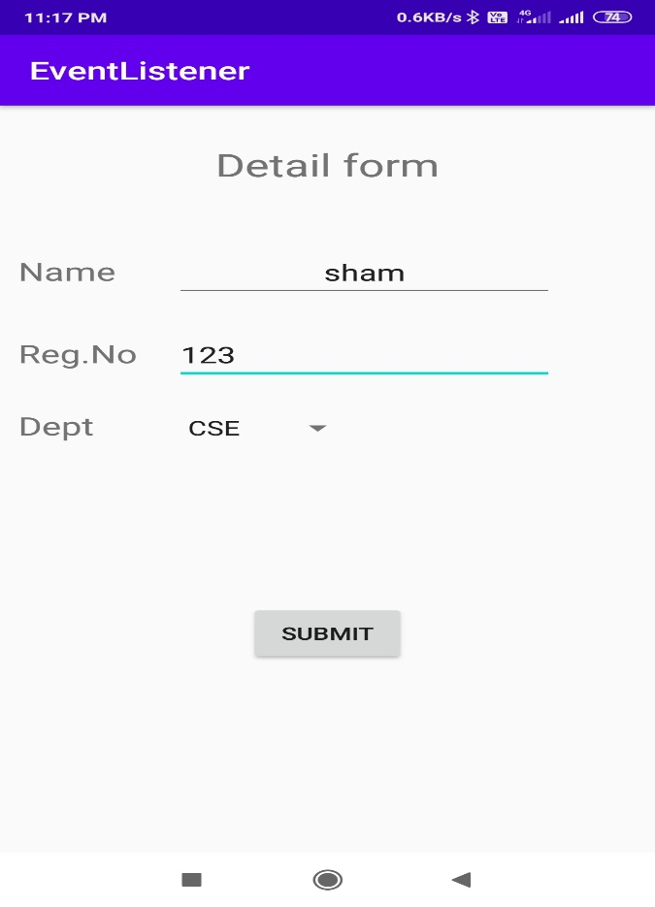

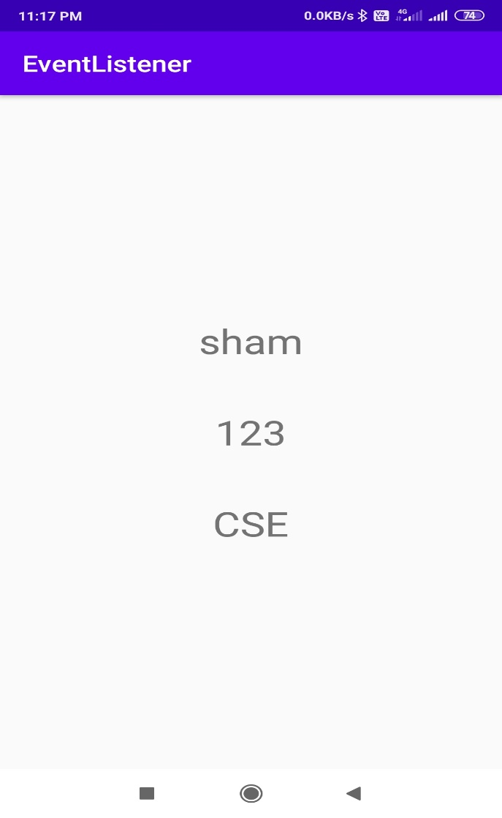

**3. Develop a standard calculator application to perform basic calculations like addition, subtraction, multiplication and division.**

**activity_main.xml:**

*<?*xml version="1.0" encoding="utf-8"*?>*<androidx.constraintlayout.widget.ConstraintLayout xmlns:android="http://schemas.android.com/apk/res/android"  
 xmlns:app="http://schemas.android.com/apk/res-auto"  
 xmlns:tools="http://schemas.android.com/tools"  
 android:layout_width="match_parent"  
 android:layout_height="match_parent"  
 tools:context=".MainActivity">  
  
 <EditText  
 android:id="@+id/n1"  
 android:layout_width="wrap_content"  
 android:layout_height="wrap_content"  
 android:layout_marginTop="153dp"  
 android:ems="10"  
 android:hint="number 1"  
 android:inputType="number"  
  
 app:layout_constraintEnd_toEndOf="parent"  
 app:layout_constraintStart_toStartOf="parent"  
 app:layout_constraintTop_toTopOf="parent"  
 tools:ignore="MissingConstraints" />  
  
 <EditText  
 android:id="@+id/n2"  
 android:layout_width="wrap_content"  
 android:layout_height="wrap_content"  
 android:ems="10"  
 android:hint="number 2"  
 android:inputType="number"  
 android:layout_marginStart="1dp"  
 android:layout_marginLeft="1dp"  
 android:layout_marginTop="45dp"  
 app:layout_constraintStart_toStartOf="@+id/n1"  
 app:layout_constraintTop_toBottomOf="@+id/n1"  
 tools:ignore="MissingConstraints,RtlCompat" />  
  
 <TextView  
 android:id="@+id/res"  
 android:layout_width="158dp"  
 android:layout_height="59dp"  
 android:layout_marginTop="36dp"  
 android:text="Result"  
 android:textColor="#000"  
 android:textSize="26sp"  
 app:layout_constraintEnd_toEndOf="parent"  
 app:layout_constraintHorizontal_bias="0.498"  
 app:layout_constraintStart_toStartOf="parent"  
 app:layout_constraintTop_toBottomOf="@+id/n2"  
 tools:ignore="MissingConstraints,MissingConstraints:" />  
  
 <Button  
 android:id="@+id/button"  
 android:layout_width="98dp"  
 android:layout_height="42dp"  
 android:layout_marginStart="76dp"  
 android:layout_marginLeft="76dp"  
 android:text="ADD"  
 app:layout_constraintBaseline_toBaselineOf="@+id/button2"  
 app:layout_constraintStart_toStartOf="parent" />  
  
 <Button  
 android:id="@+id/button2"  
 android:layout_width="wrap_content"  
 android:layout_height="wrap_content"  
 android:layout_marginStart="84dp"  
 android:layout_marginLeft="84dp"  
 android:layout_marginTop="52dp"  
 android:text="SUB"  
 app:layout_constraintStart_toEndOf="@+id/button"  
 app:layout_constraintTop_toBottomOf="@+id/res" />  
  
 <Button  
 android:id="@+id/button3"  
 android:layout_width="wrap_content"  
 android:layout_height="wrap_content"  
 android:text="Multiply"  
 android:layout_marginStart="8dp"  
 android:layout_marginLeft="8dp"  
 app:layout_constraintBaseline_toBaselineOf="@+id/button4"  
 app:layout_constraintEnd_toStartOf="@+id/button4"  
 app:layout_constraintStart_toStartOf="parent"/>  
  
 <Button  
 android:id="@+id/button4"  
 android:layout_width="wrap_content"  
 android:layout_height="wrap_content"  
 android:text="Divide"  
 android:layout_marginTop="58dp"  
 android:layout_marginEnd="14dp"  
 android:layout_marginRight="14dp"  
 app:layout_constraintEnd_toEndOf="parent"  
 app:layout_constraintStart_toEndOf="@+id/button3"  
 app:layout_constraintTop_toBottomOf="@+id/button2" />  
  
</androidx.constraintlayout.widget.ConstraintLayout>

**MainActivity.java:**

package com.example.calculator;  
import androidx.appcompat.app.AppCompatActivity;  
import android.os.Bundle;  
import android.view.View;  
import android.widget.Button;  
import android.widget.EditText;  
import android.widget.TextView;  
import android.widget.Toast;  
  
public class MainActivity extends AppCompatActivity {  
 EditText num1,num2;  
 TextView Result;  
 Button add,sub,mul,div;  
  
 @Override  
 protected void onCreate(Bundle savedInstanceState) {  
 super.onCreate(savedInstanceState);  
 setContentView(R.layout.*activity_main*);  
 num1=(EditText)findViewById(R.id.*n1*);  
 num2=(EditText)findViewById(R.id.*n2*);  
 Result=(TextView)findViewById(R.id.*res*);  
 add=(Button)findViewById(R.id.*button*);  
 sub=(Button)findViewById(R.id.*button2*);  
 mul=(Button)findViewById(R.id.*button3*);  
 div=(Button)findViewById(R.id.*button4*);  
 add.setOnClickListener(new View.OnClickListener() {  
 @Override  
 public void onClick(View v) {  
 if(num1.getText().length() !=0 && num2.getText().length() !=0)  
 {  
 double number1=Double.*parseDouble*(num1.getText().toString());  
 double number2=Double.*parseDouble*(num2.getText().toString());  
 double ans = number1 + number2;  
 Result.setText(String.*valueOf*(ans));  
  
 }  
 else  
 {  
 Toast.*makeText*(v.getContext(),"Please enter number properly",Toast.*LENGTH_SHORT*).show();  
 }  
  
 }  
 });  
 sub.setOnClickListener(new View.OnClickListener() {  
 @Override  
 public void onClick(View v) {  
 if(num1.getText()!=null && num2.getText()!=null)  
 {  
 double number1=Double.*parseDouble*(num1.getText().toString());  
 double number2=Double.*parseDouble*(num2.getText().toString());  
 double ans=number1-number2;  
 Result.setText(String.*valueOf*(ans));  
 }  
 else  
 {  
 Toast.*makeText*(v.getContext(),"Please enter number properly",Toast.*LENGTH_SHORT*).show();  
  
 }  
 }  
 });  
 mul.setOnClickListener(new View.OnClickListener() {  
 @Override  
 public void onClick(View v) {  
 if(num1.getText()!=null && num2.getText()!=null)  
 {  
 double number1=Double.*parseDouble*(num1.getText().toString());  
 double number2=Double.*parseDouble*(num2.getText().toString());  
 double ans=number1*number2;  
 Result.setText(String.*valueOf*(ans));  
  
 }  
 else  
 {  
 Toast.*makeText*(v.getContext(),"Please enter number properly",Toast.*LENGTH_SHORT*).show();  
  
 }  
 }  
 });  
 div.setOnClickListener(new View.OnClickListener() {  
 @Override  
 public void onClick(View v) {  
 if(num1.getText()!=null && num2.getText()!=null)  
 {  
 double number1=Double.*parseDouble*(num1.getText().toString());  
 double number2=Double.*parseDouble*(num2.getText().toString());  
 double ans=number1/number2;  
 Result.setText(String.*valueOf*(ans));  
 }  
 else  
 {  
 Toast.*makeText*(v.getContext(),"Please enter number properly",Toast.*LENGTH_SHORT*).show();  
 }  
 }  
 });  
 }  
}

**OUTPUT:**

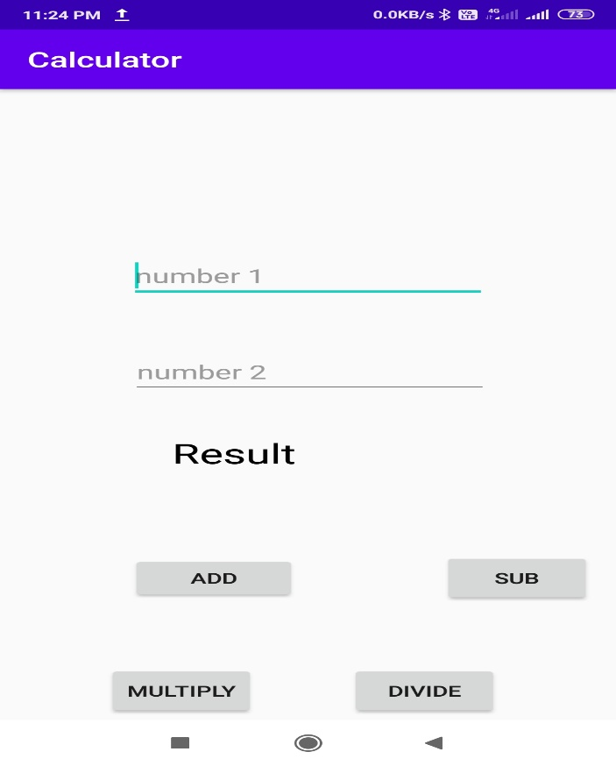

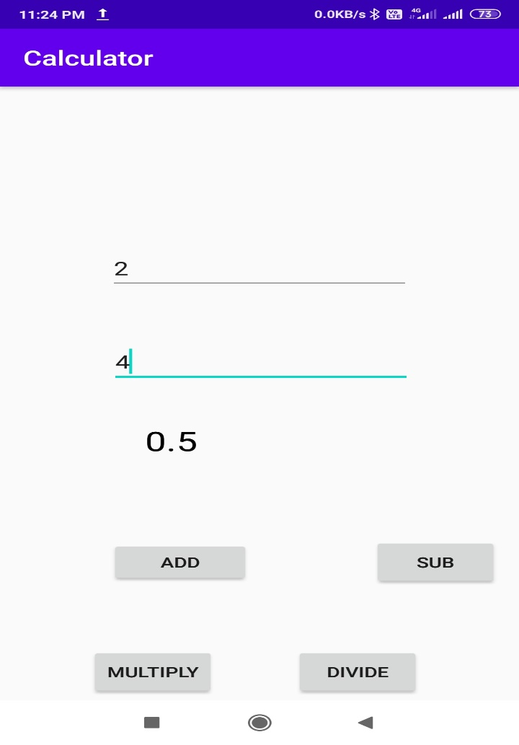

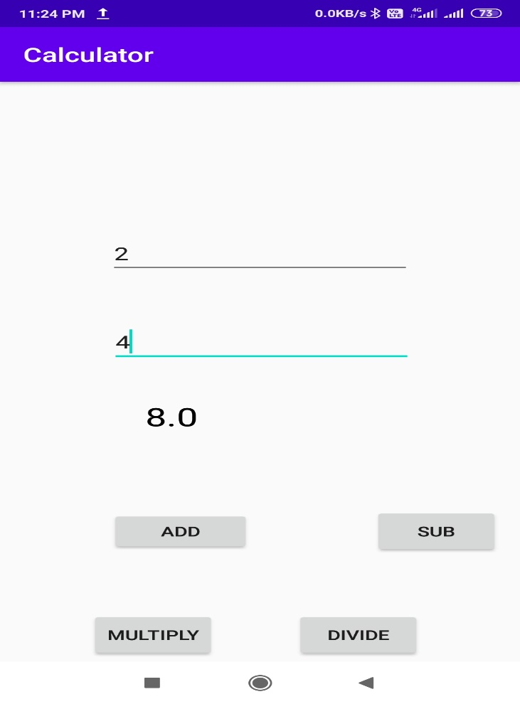

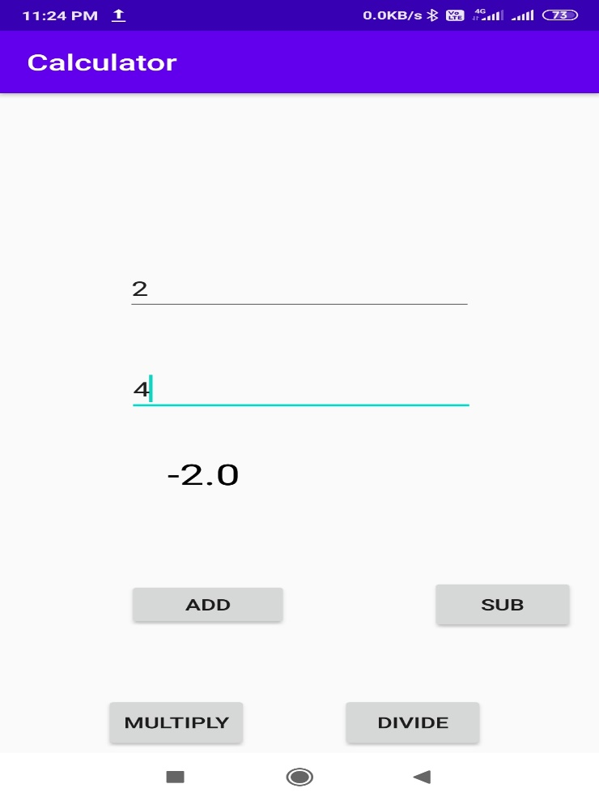

**4. Devise an application that draws basic graphical primitives (rectangle, circle) on the screen Android Application to draw Basic Graphical Primitives**

**activity_main.xml:**

*<?*xml version="1.0" encoding="utf-8"*?>*<RelativeLayout xmlns:android="http://schemas.android.com/apk/res/android"  
 xmlns:app="http://schemas.android.com/apk/res-auto"  
 xmlns:tools="http://schemas.android.com/tools"  
 android:layout_width="match_parent"  
 android:layout_height="match_parent"  
 tools:context=".MainActivity">  
  
  
 <ImageView  
 android:id="@+id/imageView"  
 android:layout_width="match_parent"  
 android:layout_height="wrap_content"  
 app:srcCompat="@android:color/transparent" />  
</RelativeLayout>

**MainActivity.java:**

package com.example.graphic;  
import androidx.appcompat.app.AppCompatActivity;  
import android.graphics.Bitmap;  
import android.graphics.Canvas;  
import android.graphics.Color;  
import android.graphics.Paint;  
import android.graphics.drawable.BitmapDrawable;  
import android.os.Bundle;  
import android.widget.ImageView;  
public class MainActivity extends AppCompatActivity {  
  
 @Override  
 protected void onCreate(Bundle savedInstanceState) {  
 super.onCreate(savedInstanceState);  
 setContentView(R.layout.*activity_main*);  
 Bitmap bg = Bitmap.*createBitmap*(720, 1280, Bitmap.Config.*ARGB_8888*);  
 ImageView i = (ImageView) findViewById(R.id.*imageView*);  
 i.setBackgroundDrawable(new BitmapDrawable(bg));  
 Canvas canvas = new Canvas(bg);  
 Paint paint = new Paint();  
 paint.setColor(Color.*BLUE*);  
 paint.setTextSize(50);  
 canvas.drawText("Rectangle", 420, 150, paint);  
 canvas.drawRect(400, 200, 650, 700, paint);  
 canvas.drawText("Circlce", 120, 150, paint);  
 canvas.drawCircle(200, 350, 150, paint);  
 canvas.drawText("Square", 120, 800, paint);  
 canvas.drawRect(50, 850, 350, 1150, paint);  
 canvas.drawText("Line", 480, 800, paint);  
 canvas.drawLine(520, 850, 520, 1150, paint);  
 }  
}

Output:

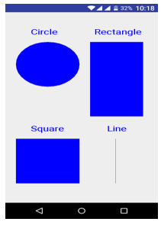

**5. Build an mobile application that create, save, update and delete data in a database**

**activity_main.xml:**

*<?*xml version="1.0" encoding="utf-8"*?>*<AbsoluteLayout xmlns:android="http://schemas.android.com/apk/res/android"  
 xmlns:app="http://schemas.android.com/apk/res-auto"  
 xmlns:tools="http://schemas.android.com/tools"  
 android:layout_width="match_parent"  
 android:layout_height="match_parent"  
 tools:context=".MainActivity">  
  
 <TextView  
 android:layout_width="wrap_content"  
 android:layout_height="wrap_content"  
 android:text="Student Details"  
 app:layout_constraintBottom_toBottomOf="parent"  
 android:layout_x="50dp"  
 android:layout_y="20dp"  
 android:textSize="30sp"/>  
  
 <TextView  
 android:layout_width="121dp"  
 android:layout_height="51dp"  
 android:layout_x="28dp"  
 android:layout_y="102dp"  
 android:text="Enter Rollno"  
 android:textSize="20sp" />  
  
  
  
 <EditText  
 android:id="@+id/Rollno"  
 android:layout_width="150dp"  
 android:layout_height="wrap_content"  
 android:layout_x="217dp"  
 android:layout_y="108dp"  
 android:inputType="number"  
 android:textSize="20sp" />  
  
 <TextView  
 android:layout_width="119dp"  
 android:layout_height="54dp"  
 android:layout_x="26dp"  
 android:layout_y="186dp"  
 android:text="Enter Name"  
 android:textSize="20sp" />  
  
 <EditText  
 android:id="@+id/Name"  
 android:layout_width="150dp"  
 android:layout_height="wrap_content"  
 android:layout_x="217dp"  
 android:layout_y="181dp"  
 android:inputType="text"  
 android:textSize="20sp" />  
  
 <TextView  
 android:layout_width="118dp"  
 android:layout_height="46dp"  
 android:layout_x="31dp"  
 android:layout_y="263dp"  
 android:text="Enter Marks"  
 android:textSize="20sp" />  
  
 <EditText  
 android:id="@+id/Marks"  
 android:layout_width="150dp"  
 android:layout_height="wrap_content"  
 android:layout_x="216dp"  
 android:layout_y="261dp"  
 android:inputType="number"  
 android:textSize="20sp"/>  
 <Button  
 android:id="@+id/Insert"  
 android:layout_width="150dp"  
 android:layout_height="wrap_content"  
 android:layout_x="25dp"  
 android:layout_y="350dp"  
 android:text="Insert"  
 android:textSize="30sp"/>  
 <Button  
 android:id="@+id/Delete"  
 android:layout_width="150dp"  
 android:layout_height="wrap_content"  
 android:layout_x="200dp"  
 android:layout_y="350dp"  
 android:text="Delete"  
 android:textSize="30sp"/>  
 <Button  
 android:id="@+id/Update"  
 android:layout_width="150dp"  
 android:layout_height="wrap_content"  
 android:layout_x="25dp"  
 android:layout_y="450dp"  
 android:text="Update"  
 android:textSize="30sp"/>  
 <Button  
 android:id="@+id/View"  
 android:layout_width="150dp"  
 android:layout_height="wrap_content"  
 android:layout_x="200dp"  
 android:layout_y="450dp"  
 android:text="View"  
 android:textSize="30sp"/>  
 <Button  
 android:id="@+id/ViewAll"  
 android:layout_width="150dp"  
 android:layout_height="wrap_content"  
 android:layout_x="100dp"  
 android:layout_y="540dp"  
 android:text="ViewAll"  
 android:textSize="30sp"/>  
</AbsoluteLayout>

**MainActivity.java:**

package com.example.prgm5database;  
  
import androidx.appcompat.app.AppCompatActivity;  
  
import android.app.Activity;  
import android.content.Context;  
import android.database.sqlite.SQLiteDatabase;  
import android.os.Bundle;  
import android.view.View;  
import android.view.View.OnClickListener;  
import android.widget.Button;  
import android.widget.EditText;  
import android.app.AlertDialog.Builder;  
import android.database.Cursor;  
  
public class MainActivity extends Activity implements OnClickListener {  
 EditText Rollno, Name, Marks;  
 Button Insert, Delete, Update, View, ViewAll;  
 SQLiteDatabase db;  
  
 @Override  
 protected void onCreate(Bundle savedInstanceState) {  
 super.onCreate(savedInstanceState);  
 setContentView(R.layout.*activity_main*);  
 Rollno = (EditText) findViewById(R.id.*Rollno*);  
 Name = (EditText) findViewById(R.id.*Name*);  
 Marks = (EditText) findViewById(R.id.*Marks*);  
 Insert = (Button) findViewById(R.id.*Insert*);  
 Delete = (Button) findViewById(R.id.*Delete*);  
 Update = (Button) findViewById(R.id.*Update*);  
 View = (Button) findViewById(R.id.*View*);  
 ViewAll = (Button) findViewById(R.id.*ViewAll*);  
 Insert.setOnClickListener(this);  
 Delete.setOnClickListener(this);  
 Update.setOnClickListener(this);  
 View.setOnClickListener(this);  
 ViewAll.setOnClickListener(this);  
 db = openOrCreateDatabase("StudentDB", Context.*MODE_PRIVATE*, null);  
 db.execSQL("CREATE TABLE IF NOT EXISTS student(rollno VARCHAR,name VARCHAR,marks VARCHAR);");  
  
 }  
  
 public void onClick(android.view.View view) {  
 if (view == Insert) {  
 if (Rollno.getText().toString().trim().length() == 0 ||  
 Name.getText().toString().trim().length() == 0 ||  
 Marks.getText().toString().trim().length() == 0) {  
 showMessage("Error", "Please enter all values");  
 return;  
 }  
 db.execSQL("INSERT INTO student VALUES('" + Rollno.getText() + "','" + Name.getText() + "','" + Marks.getText() + "');");  
 showMessage("Success", "Record added");  
 clearText();  
 }  
 if (view == Delete) {  
 if (Rollno.getText().toString().trim().length() == 0) {  
 showMessage("Error", "Please enter Rollno");  
 return;  
 }  
 Cursor c = db.rawQuery("SELECT * FROM student WHERE rollno='" + Rollno.getText() + "'", null);  
 if (c.moveToFirst()) {  
 db.execSQL("DELETE FROM student WHERE rollno='" + Rollno.getText() + "'");  
  
 showMessage("Success", "Record Deleted");  
 } else {  
 showMessage("Error", "Invalid Rollno");  
 }  
 clearText();  
 }  
 if (view == Update) {  
 if (Rollno.getText().toString().trim().length() == 0) {  
 showMessage("Error", "Please enter Rollno");  
 return;  
 }  
 Cursor c = db.rawQuery("SELECT * FROM student WHERE rollno='"+Rollno.getText() + "'", null);  
 if (c.moveToFirst()) {  
 db.execSQL("UPDATE student SET name='" + Name.getText() + "',marks='" + Marks.getText() + "'WHERE rollno='" + Rollno.getText() + "'");  
 showMessage("Success", "Record Modified");  
 } else {  
 showMessage("Error", "Invalid Rollno");  
 }  
 clearText();  
 }  
 if (view == View) {  
 if (Rollno.getText().toString().trim().length() == 0) {  
 showMessage("Error", "Please enter Rollno");  
 return;  
 }  
 Cursor c = db.rawQuery("SELECT * FROM student WHERE rollno='" + Rollno.getText() + "'", null);  
 if (c.moveToFirst()) {  
 Name.setText(c.getString(1));  
 Marks.setText(c.getString(2));  
  
 } else {  
 showMessage("Error","Invalid Rollno");  
 clearText();  
 }  
 }  
 if (view == ViewAll) {  
 Cursor c = db.rawQuery("SELECT * FROM student ", null);  
 if (c.getCount() == 0) {  
 showMessage("Error", "No record Found");  
 return;  
 }  
 StringBuffer buffer = new StringBuffer();  
 while (c.moveToNext()) {  
 buffer.append("Rollno:" + c.getString(0) + "\n");  
 buffer.append("Name:" + c.getString(1) + "\n");  
 buffer.append("Marks:" + c.getString(2) + "\n");  
 }  
 showMessage("Student Details", buffer.toString());  
 }  
 }  
  
 public void showMessage(String title, String message) {  
 Builder builder = new Builder(this);  
 builder.setCancelable(true);  
 builder.setTitle(title);  
 builder.setMessage(message);  
 builder.show();  
 }  
 public void clearText()  
 {  
 Rollno.setText("");  
 Name.setText("");  
 Marks.setText("");  
 Rollno.requestFocus();  
  
 }  
  
}

Output:

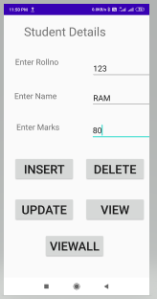

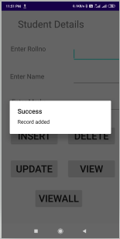

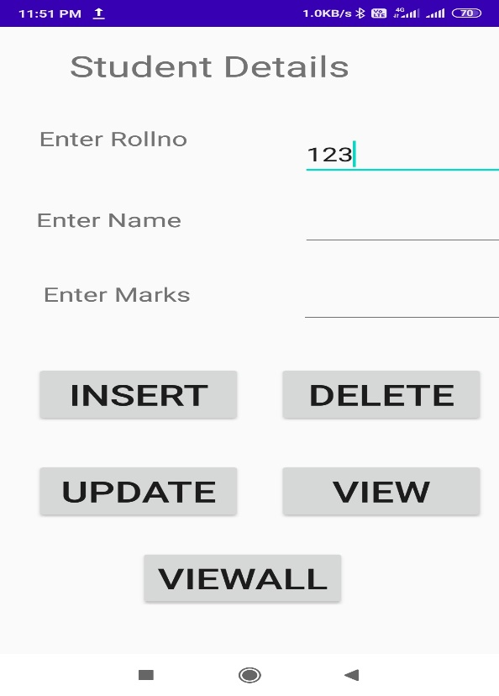

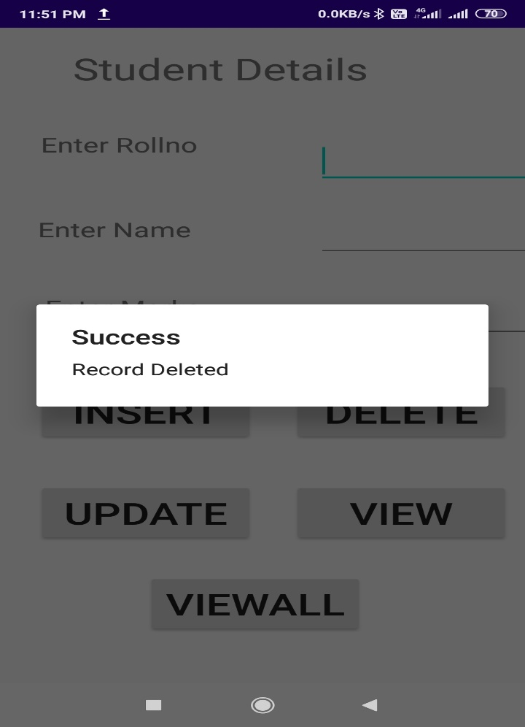

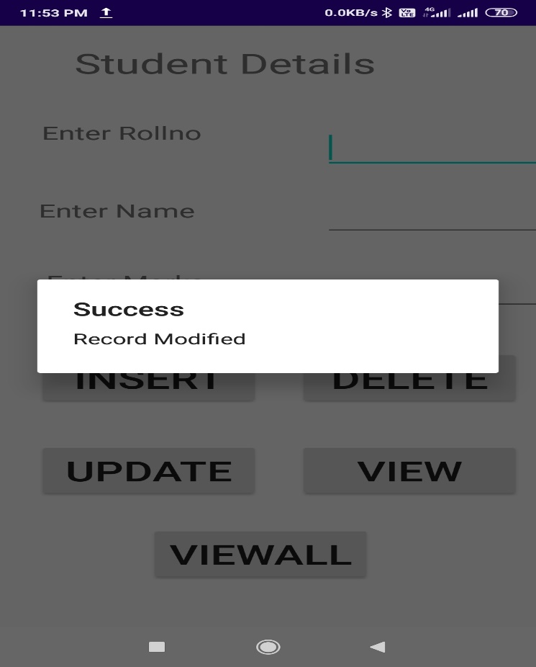

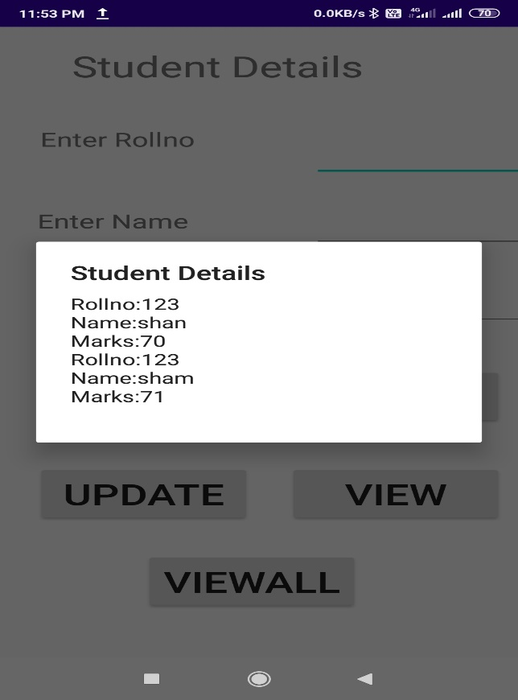

**6. Devise an application that implements Multi threading**

**activity_main.xml:**

*<?*xml version="1.0" encoding="utf-8"*?>*<LinearLayout xmlns:android="http://schemas.android.com/apk/res/android"  
 xmlns:app="http://schemas.android.com/apk/res-auto"  
 xmlns:tools="http://schemas.android.com/tools"  
 android:layout_width="match_parent"  
 android:layout_height="match_parent"  
 android:orientation="vertical"  
 tools:context=".MainActivity">  
  
  
 <ImageView  
 android:id="@+id/imageView"  
 android:layout_width="250dp"  
 android:layout_height="250dp"  
 android:layout_gravity="center"  
 android:layout_margin="50dp" />  
  
 <Button  
 android:id="@+id/button"  
 android:layout_width="wrap_content"  
 android:layout_height="wrap_content"  
 android:layout_gravity="center"  
 android:layout_margin="10dp"  
 android:text="load Image1 "/>  
  
 <Button  
 android:id="@+id/button2"  
 android:layout_width="wrap_content"  
 android:layout_height="wrap_content"  
 android:layout_gravity="center"  
 android:layout_margin="10dp"  
 android:text="load Image2 " />  
 />  
</LinearLayout>

**MainActivity.java:**

package com.example.mutlithreading;  
import androidx.appcompat.app.AppCompatActivity;  
import android.os.Bundle;  
import android.view.View;  
import android.widget.Button;  
import android.widget.ImageView;  
  
public class MainActivity extends AppCompatActivity {  
ImageView img;  
Button b1,b2;  
  
 @Override  
 protected void onCreate(Bundle savedInstanceState) {  
 super.onCreate(savedInstanceState);  
 setContentView(R.layout.*activity_main*);  
 b1=(Button)findViewById(R.id.*button*);  
 b2=(Button)findViewById(R.id.*button2*);  
 img=(ImageView)findViewById(R.id.*imageView*);  
 b1.setOnClickListener(new View.OnClickListener() {  
 @Override  
 public void onClick(View v) {  
 new Thread(new Runnable() {  
 @Override  
 public void run() {  
 img.post(new Runnable()  
 {  
 public void run()  
 {  
 img.setImageResource(R.drawable.*image1*);  
 }  
 });  
 }  
 }).start();  
 }  
 });  
 b2.setOnClickListener(new View.OnClickListener() {  
 @Override  
 public void onClick(View v) {  
 new Thread(new Runnable()  
 {  
  
 @Override  
 public void run() {  
 img.post(new Runnable()  
 {  
 public void run()  
 {  
 img.setImageResource(R.drawable.*image2*);  
 }  
 });  
 }  
 }).start();  
 }  
 });  
 }  
}

**Output:**

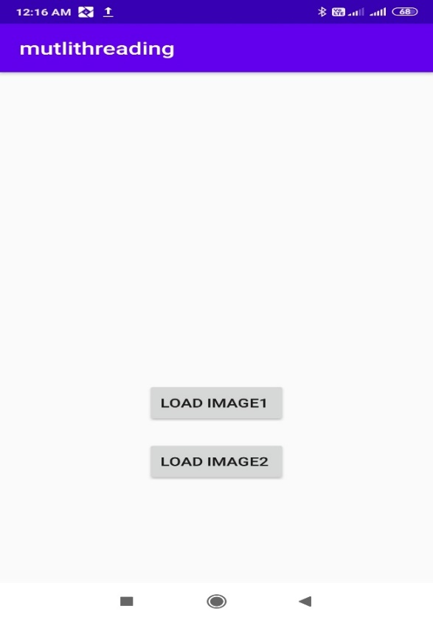

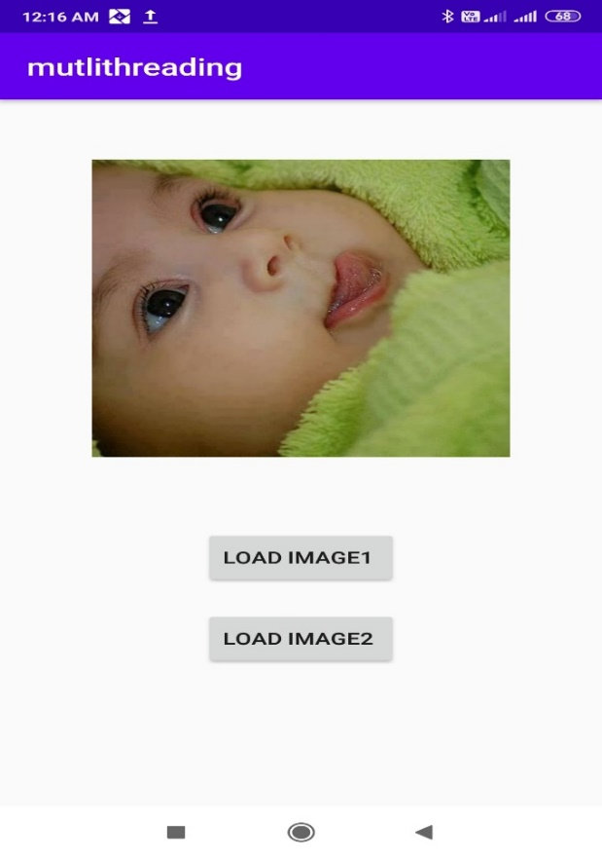

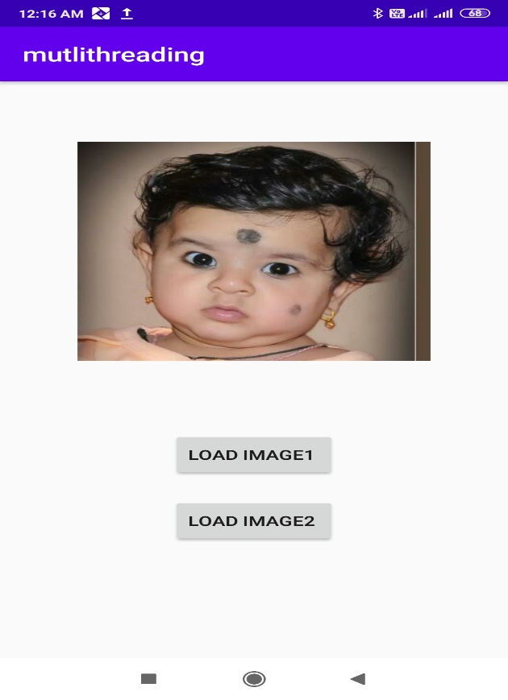

**7. Develop a mobile application that uses GPS location information**

**acivity_main.xml:**

*<?*xml version="1.0" encoding="utf-8"*?>*<RelativeLayout xmlns:android="http://schemas.android.com/apk/res/android"  
 xmlns:app="http://schemas.android.com/apk/res-auto"  
 xmlns:tools="http://schemas.android.com/tools"  
 android:id="@+id/relativeLayout"  
 android:layout_width="match_parent"  
 android:layout_height="match_parent"  
 tools:context=".MainActivity">  
 <Button  
 android:id="@+id/show_Location"  
 android:layout_width="wrap_content"  
 android:layout_height="wrap_content"  
 android:text="Show_Location"  
 android:layout_centerVertical="true"  
 android:layout_centerHorizontal="true"  
 />  
  
</RelativeLayout>

**MainAcivity.java:**

package com.example.gpslocation;  
  
import androidx.appcompat.app.AppCompatActivity;  
import androidx.core.app.ActivityCompat;  
import androidx.core.content.ContextCompat;  
  
import android.Manifest;  
import android.app.Activity;  
import android.content.pm.PackageManager;  
import android.os.Build;  
import android.os.Bundle;  
import android.view.View;  
import android.widget.Button;  
import android.widget.Toast;  
  
import static android.os.Build.VERSION_CODES.*M*;  
  
public class MainActivity extends AppCompatActivity {  
Button btnShowLocation;  
GPStrace gps;  
 @Override  
 protected void onCreate(Bundle savedInstanceState) {  
 super.onCreate(savedInstanceState);  
 setContentView(R.layout.*activity_main*);  
 btnShowLocation=(Button)findViewById(R.id.*show_Location*);  
 if(Build.VERSION.*SDK_INT* >= Build.VERSION_CODES.*M*) {  
 if(ContextCompat.*checkSelfPermission*(MainActivity.this, Manifest.permission.*ACCESS_FINE_LOCATION*)!= PackageManager.*PERMISSION_GRANTED*|| ContextCompat.*checkSelfPermission*(MainActivity.this,Manifest.permission.*ACCESS_COARSE_LOCATION*)!=PackageManager.*PERMISSION_GRANTED*) {  
 ActivityCompat.*requestPermissions*(MainActivity.this,new String[] {Manifest.permission.*ACCESS_FINE_LOCATION*},1);  
 }  
  
 }  
 btnShowLocation.setOnClickListener(new View.OnClickListener() {  
 @Override  
 public void onClick(View v) {  
 gps=new GPStrace(MainActivity.this);  
 if(gps.canGetLocation()) {  
 double latitude=gps.getLatitude();  
 double longitude=gps.getLongitude();  
 Toast.*makeText*(getApplicationContext(),"Your Location is \nLat:"+latitude+ "\nLong:"+longitude, Toast.*LENGTH_LONG*).show();  
 } else {  
 gps.showSettingAlert();  
 }  
 }  
 });  
 }  
}

**GPStrace.java:**

package com.example.gpslocation;  
  
import android.Manifest;  
import android.app.AlertDialog;  
import android.app.Service;  
import android.content.Context;  
import android.content.DialogInterface;  
import android.content.Intent;  
import android.content.pm.PackageManager;  
import android.location.Location;  
import android.location.LocationListener;  
import android.location.LocationManager;  
import android.os.Bundle;  
import android.os.IBinder;  
import android.provider.Settings;  
import android.widget.Toast;  
import androidx.annotation.NonNull;  
import androidx.core.app.ActivityCompat;  
  
import static android.location.LocationManager.*NETWORK_PROVIDER*;  
  
public class GPStrace extends Service implements LocationListener {  
 private final Context context;  
 boolean isGPSEnabled=false;  
 boolean canGetLocation=false;  
 boolean isNetworkEnabled=false;  
 Location location;  
 double latitude;  
 double longitude;  
 private static final long *MIN_DISTANCE_CHANGE_FOR_UPDATES*=10;  
 private static final long *MIN_TIME_BW_UPDATES*=1000*60*1;  
 protected LocationManager locationManager;  
 public GPStrace(Context context)  
 {  
 this.context=context;  
 getLocation();  
 }  
 public Location getLocation() {  
 try{  
 locationManager=(LocationManager)context.getSystemService(*LOCATION_SERVICE*);  
 isGPSEnabled=locationManager.isProviderEnabled(LocationManager.*GPS_PROVIDER*);  
 isNetworkEnabled=locationManager.isProviderEnabled(*NETWORK_PROVIDER*);  
 if(!isGPSEnabled && !isNetworkEnabled) {  
 Toast.*makeText*(context,"please Enable GPS!",Toast.*LENGTH_LONG*).show();  
 } else {  
 this.canGetLocation=true;  
 if(isNetworkEnabled) {  
  
 if(ActivityCompat.*checkSelfPermission*(context, Manifest.permission.*ACCESS_FINE_LOCATION*)== PackageManager.*PERMISSION_GRANTED* && ActivityCompat.*checkSelfPermission*(context,Manifest.permission.*ACCESS_COARSE_LOCATION*)==PackageManager.*PERMISSION_GRANTED*) {  
 locationManager.requestLocationUpdates(*NETWORK_PROVIDER*,*MIN_TIME_BW_UPDATES*,*MIN_DISTANCE_CHANGE_FOR_UPDATES*,this);  
 } else {  
 Toast.*makeText*(context,"Permission Not Granted !!",Toast.*LENGTH_LONG*).show();  
 }  
  
 }  
 if(locationManager!=null) {  
 location=locationManager.getLastKnownLocation(*NETWORK_PROVIDER*);  
 if(location!=null) {  
 latitude=location.getLatitude();  
 longitude=location.getLongitude();  
  
 }  
 }  
 }  
 if(isGPSEnabled) {  
 if(location==null) {  
 locationManager.requestLocationUpdates(LocationManager.*GPS_PROVIDER*,*MIN_TIME_BW_UPDATES*,*MIN_DISTANCE_CHANGE_FOR_UPDATES*,this);  
 if(locationManager!=null) {  
 location=locationManager.getLastKnownLocation(*NETWORK_PROVIDER*);  
 if(location!=null) {  
 latitude=location.getLatitude();  
 longitude=location.getLongitude();  
 }  
 }  
 }  
 }  
 }  
 catch(Exception e)  
 {  
 e.printStackTrace();  
 }  
 return location;  
  
 }  
 public void stopUsingGPS() {  
 if(locationManager!=null) {  
 locationManager.removeUpdates(GPStrace.this);  
 }  
 }  
 public double getLatitude() {  
 if(locationManager!=null) {  
 latitude=location.getLatitude();  
 }  
 return latitude;  
 }  
 public double getLongitude() {  
 if(location!=null) {  
 longitude=location.getLongitude();  
  
 }  
 return longitude;  
 }  
 public boolean canGetLocation() {  
 return this.canGetLocation;  
 }  
 public void showSettingAlert() {  
 AlertDialog.Builder alertDialog=new AlertDialog.Builder(context);  
 alertDialog.setTitle("GPS is setting");  
 alertDialog.setMessage("GPS is not enabled. Do you want to go to setting menu");  
 alertDialog.setPositiveButton("setting", new DialogInterface.OnClickListener() {  
 @Override  
 public void onClick(DialogInterface dialog, int which) {  
 Intent intent=new Intent(Settings.*ACTION_LOCATION_SOURCE_SETTINGS*);  
 context.startActivity(intent);  
 }  
 });  
 alertDialog.setNegativeButton("cancel", new DialogInterface.OnClickListener() {  
 @Override  
 public void onClick(DialogInterface dialog, int which) {  
 dialog.cancel();  
 }  
 });  
 alertDialog.show();  
 }  
 @Override  
 public IBinder onBind(Intent intent) {  
 return null;  
 }  
  
 @Override  
 public void onLocationChanged(Location location) {  
  
 }  
 @Override  
 public void onProviderDisabled(String provider) {  
  
 }  
 @Override  
 public void onProviderEnabled(String provider) {  
 }  
 @Override  
 public void onStatusChanged(String provider, int status, Bundle extras) {  
  
 }  
  
}

**AndroidManifest.xml:**

*<?*xml version="1.0" encoding="utf-8"*?>*<manifest xmlns:android="http://schemas.android.com/apk/res/android"  
 package="com.example.gpslocation">  
 <uses-permission android:name="android.permission.ACCESS_COARSE_LOCATION"/>  
 <uses-permission android:name="android.permission.ACCESS_FINE_LOCATION"/>  
 <uses-permission android:name="android.permission.INTERNET"/>  
 <application  
 android:allowBackup="true"  
 android:icon="@mipmap/ic_launcher"  
 android:label="@string/app_name"  
 android:roundIcon="@mipmap/ic_launcher_round"  
 android:supportsRtl="true"  
 android:theme="@style/AppTheme">  
 <activity android:name=".MainActivity">  
 <intent-filter>  
 <action android:name="android.intent.action.MAIN" />  
  
 <category android:name="android.intent.category.LAUNCHER" />  
 </intent-filter>  
 </activity>  
 </application>  
  
</manifest>

**Output:**

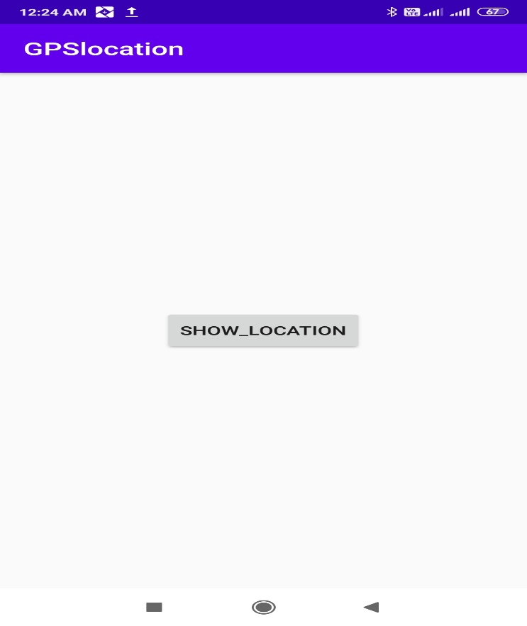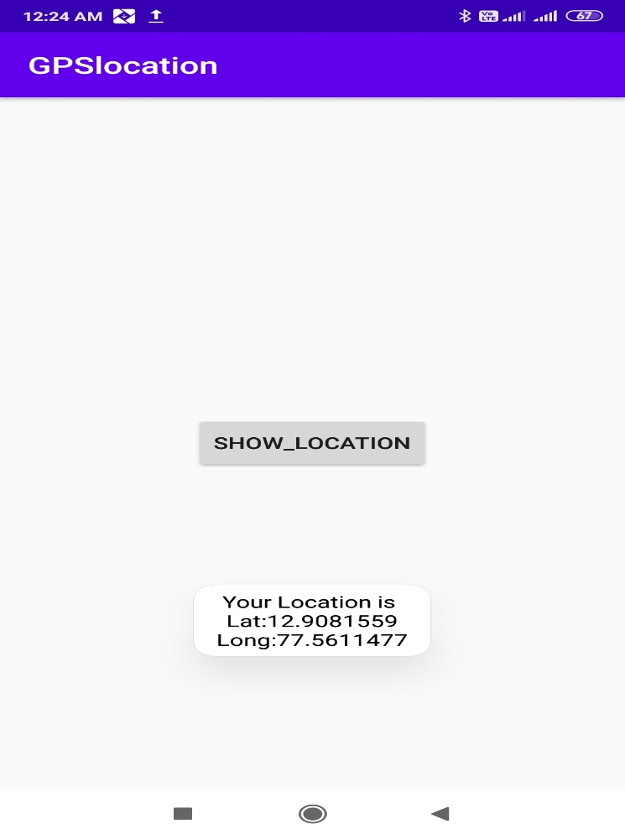

**8. Create an application that writes data to the SD card.**

**AndroidManifest.xml:**

*<?*xml version="1.0" encoding="utf-8"*?>*<manifest xmlns:android="http://schemas.android.com/apk/res/android"  
 package="com.example.sdcard">  
 <uses-permission android:name="android.permission.WRITE_EXTERNAL_STORAGE"/>  
  
 <application  
 android:allowBackup="true"  
 android:icon="@mipmap/ic_launcher"  
 android:label="@string/app_name"  
 android:roundIcon="@mipmap/ic_launcher_round"  
 android:supportsRtl="true"  
 android:theme="@style/AppTheme">  
 <activity android:name=".MainActivity">  
 <intent-filter>  
 <action android:name="android.intent.action.MAIN" />  
  
 <category android:name="android.intent.category.LAUNCHER" />  
 </intent-filter>  
 </activity>  
 </application>  
  
</manifest>

**Activity_main.xml:**

*<?*xml version="1.0" encoding="utf-8"*?>*<LinearLayout xmlns:android="http://schemas.android.com/apk/res/android"  
 xmlns:app="http://schemas.android.com/apk/res-auto"  
 xmlns:tools="http://schemas.android.com/tools"  
 android:layout_width="match_parent"  
 android:layout_height="match_parent"  
 android:orientation="vertical"  
 android:layout_margin="20dp"  
 tools:context=".MainActivity">  
 <EditText  
 android:id="@+id/editText"  
 android:layout_width="match_parent"  
 android:layout_height="wrap_content"  
 android:singleLine="true"  
 android:textSize="30dp"  
 />  
 <Button  
 android:id="@+id/button"  
 android:layout_width="match_parent"  
 android:layout_height="wrap_content"  
 android:layout_margin="10dp"  
 android:text="WriteData"  
 android:textSize="30dp"/>  
 <Button  
 android:id="@+id/button2"  
 android:layout_width="match_parent"  
 android:layout_height="wrap_content"  
 android:layout_margin="10dp"  
 android:text="Read Data"  
 android:textSize="30dp"/>  
 <Button  
 android:id="@+id/button3"  
 android:layout_width="match_parent"  
 android:layout_height="wrap_content"  
 android:layout_margin="10dp"  
 android:text="Clear"  
 android:textSize="30dp"/>  
  
  
</LinearLayout>

**MainActivity.java:**

package com.example.sdcard;  
  
import androidx.appcompat.app.AppCompatActivity;  
  
import android.os.Bundle;  
import android.view.View;  
import android.widget.Button;  
import android.widget.EditText;  
import android.widget.Toast;  
  
import java.io.BufferedReader;  
import java.io.File;  
import java.io.FileInputStream;  
import java.io.FileOutputStream;  
import java.io.InputStreamReader;  
  
public class MainActivity extends AppCompatActivity {  
EditText e1;  
Button write,read,clear;  
 @Override  
 protected void onCreate(Bundle savedInstanceState) {  
 super.onCreate(savedInstanceState);  
 setContentView(R.layout.*activity_main*);  
 e1=(EditText)findViewById(R.id.*editText*);  
 write=(Button)findViewById(R.id.*button*);  
 read=(Button)findViewById(R.id.*button2*);  
 clear=(Button)findViewById(R.id.*button3*);  
 write.setOnClickListener(new View.OnClickListener() {  
 @Override  
 public void onClick(View v) {  
 String message=e1.getText().toString();  
 try {  
 File f=new File("/sdcard/myfile.txt");  
 f.createNewFile();  
 FileOutputStream fout=new FileOutputStream(f);  
 fout.write(message.getBytes());  
 fout.close();  
 Toast.*makeText*(getBaseContext(),"Data written is SDCARD",Toast.*LENGTH_LONG*).show();  
  
 }  
 catch(Exception e) {  
 Toast.*makeText*(getBaseContext(),e.getMessage(),Toast.*LENGTH_LONG*).show();  
 }  
 }  
  
 });  
 read.setOnClickListener(new View.OnClickListener() {  
 @Override  
 public void onClick(View v) {  
 String message;  
 String buf="";  
 try {  
 File f=new File("/sdcard/myfile.txt");  
 FileInputStream fin=new FileInputStream(f);  
 BufferedReader br=new BufferedReader(new InputStreamReader(fin));  
 while((message=br.readLine())!=null)  
 {  
 buf += message;  
  
 }  
 e1.setText(buf);  
 br.close();  
 fin.close();  
 Toast.*makeText*(getBaseContext(),"Data Received fromSDCARD",Toast.*LENGTH_LONG*).show();;  
  
 }  
 catch(Exception e) {  
 Toast.*makeText*(getBaseContext(),e.getMessage(),Toast.*LENGTH_LONG*).show();  
  
 }  
 }  
 });  
 clear.setOnClickListener(new View.OnClickListener() {  
 @Override  
 public void onClick(View v) {  
 e1.setText("");  
 }  
 });  
  
 }  
}

**Output:**

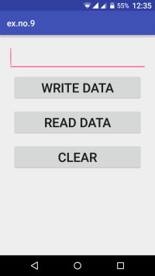 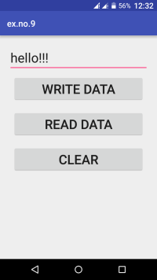

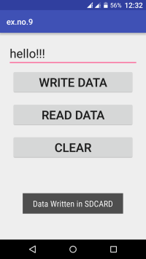 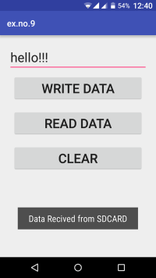

**9. Implement an application that creates an alert upon receiving a message.**

**Activity_main.xml:**

*<?*xml version="1.0" encoding="utf-8"*?>*<LinearLayout xmlns:android="http://schemas.android.com/apk/res/android"  
 xmlns:app="http://schemas.android.com/apk/res-auto"  
 xmlns:tools="http://schemas.android.com/tools"  
 android:layout_width="match_parent"  
 android:layout_height="match_parent"  
 android:layout_margin="10dp"  
 android:orientation="vertical"  
 tools:context=".MainActivity">  
  
 <TextView  
 android:layout_width="wrap_content"  
 android:layout_height="wrap_content"  
 android:text="Message"  
 android:textSize="30sp" />  
 <EditText  
 android:id="@+id/editText"  
 android:layout_width="match_parent"  
 android:layout_height="wrap_content"  
 android:singleLine="true"  
 android:textSize="30sp"/>  
 <Button  
 android:id="@+id/button"  
 android:layout_width="wrap_content"  
 android:layout_height="wrap_content"  
 android:layout_margin="30dp"  
 android:layout_gravity="center"  
 android:text="Notify"  
 android:textSize="30sp"/>  
  
</LinearLayout>

**MainActivity.java**:

package com.example.prgm9alert;  
  
import androidx.appcompat.app.AppCompatActivity;  
import androidx.annotation.RequiresApi;  
import android.app.Notification;  
import android.app.NotificationChannel;  
import android.app.NotificationManager;  
import android.app.PendingIntent;  
import android.content.Intent;  
import android.os.Build;  
import android.os.Bundle;  
import android.view.View;  
import android.widget.Button;  
import android.widget.EditText;  
  
public class MainActivity extends AppCompatActivity {  
Button notify;  
 EditText e1;  
  
 @RequiresApi(api = Build.VERSION_CODES.*O*)  
 @Override  
 protected void onCreate(Bundle savedInstanceState) {  
 super.onCreate(savedInstanceState);  
 setContentView(R.layout.*activity_main*);  
 notify=(Button)findViewById(R.id.*button*);  
 e1=(EditText)findViewById(R.id.*editText*);  
 final NotificationManager manager=(NotificationManager)getSystemService(*NOTIFICATION_SERVICE*);;  
 final String CHANNEL_ONE_ID="com.example.prgm9alert";  
 final String CHANNEL_ONE_NAME="Channel One";  
 NotificationChannel notificationChannel=new NotificationChannel(CHANNEL_ONE_ID,CHANNEL_ONE_NAME,NotificationManager.*IMPORTANCE_HIGH*);  
 manager.createNotificationChannel(notificationChannel);  
 notify.setOnClickListener(new View.OnClickListener() {  
 @Override  
 public void onClick(View v) {  
 Intent intent=new Intent(MainActivity.this,MainActivity.class);  
 PendingIntent pending=PendingIntent.*getActivity*(MainActivity.this,0,intent,0);  
 Notification noti=new Notification.Builder(MainActivity.this,CHANNEL_ONE_ID).setContentTitle("New Notification").setContentText(e1.getText().toString()).setSmallIcon(R.mipmap.*ic_launcher*).setContentIntent(pending).build();  
 NotificationManager manager=(NotificationManager)getSystemService(*NOTIFICATION_SERVICE*);  
 noti.flags |= Notification.*FLAG_AUTO_CANCEL*;  
 manager.notify(0,noti);  
 }  
 });  
 }  
}

**AndroidMainfest.xml:**

*<?*xml version="1.0" encoding="utf-8"*?>*<manifest xmlns:android="http://schemas.android.com/apk/res/android"  
 package="com.example.prgm9alert">  
<uses-permission android:name="android.permission.WRITE_EXTERNAL_STORAGE"></uses-permission>  
 <application  
 android:allowBackup="true"  
 android:icon="@mipmap/ic_launcher"  
 android:label="@string/app_name"  
 android:roundIcon="@mipmap/ic_launcher_round"  
 android:supportsRtl="true"  
 android:theme="@style/AppTheme">  
 <activity android:name=".MainActivity">  
 <intent-filter>  
 <action android:name="android.intent.action.MAIN" />  
  
 <category android:name="android.intent.category.LAUNCHER" />  
 </intent-filter>  
 </activity>  
 </application>  
  
</manifest>

Output:

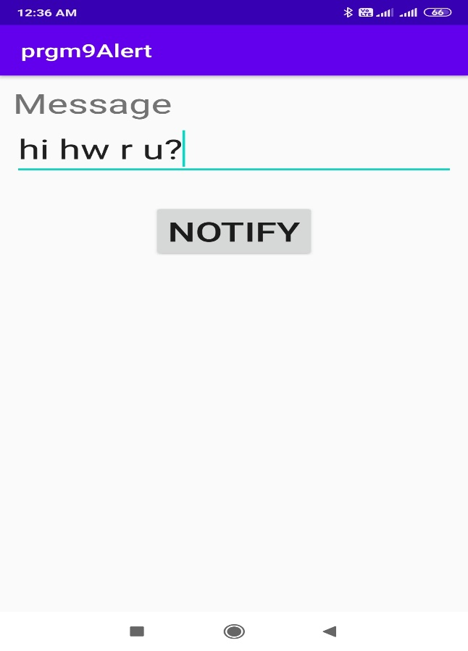 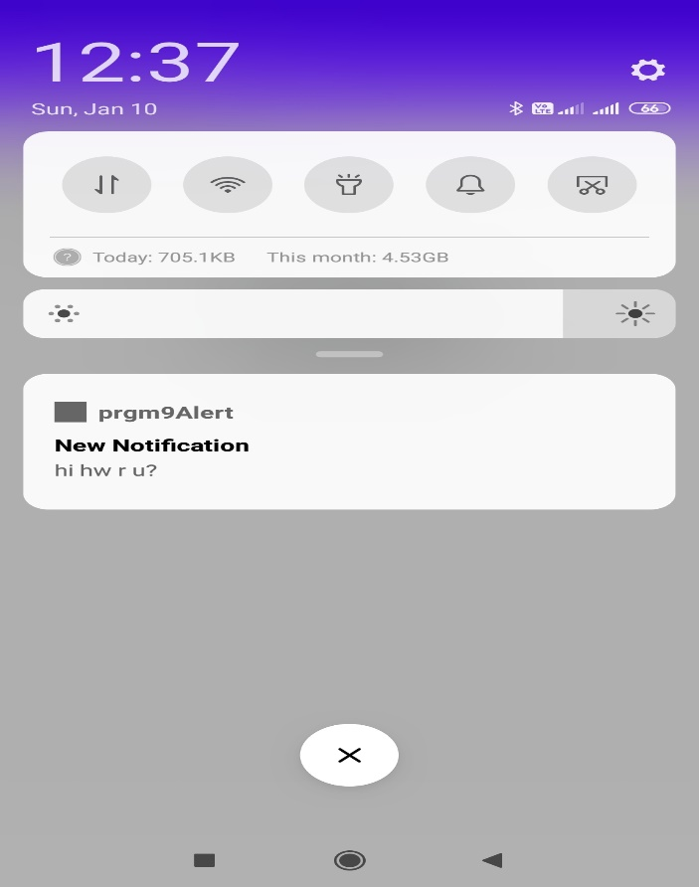

**10. Devise a mobile application that creates alarm clock**

**activity_main.xml:**

*<?*xml version="1.0" encoding="utf-8"*?>*<LinearLayout xmlns:android="http://schemas.android.com/apk/res/android"  
 xmlns:app="http://schemas.android.com/apk/res-auto"  
 xmlns:tools="http://schemas.android.com/tools"  
 android:layout_width="match_parent"  
 android:layout_height="match_parent"  
 android:orientation="vertical"  
 tools:context=".MainActivity">  
  
 <TimePicker  
 android:id="@+id/timepicker"  
 android:layout_width="wrap_content"  
 android:layout_height="wrap_content"  
 android:layout_gravity="center"/>  
 <ToggleButton  
 android:id="@+id/toggleButton"  
 android:layout_width="wrap_content"  
 android:layout_height="wrap_content"  
 android:layout_gravity="center"  
 android:layout_margin="20dp"  
 android:checked="false"  
 android:onClick="OnToggleClicked"/>  
</LinearLayout>

**MainActivity.java:**

package com.example.prgm10alarm;  
  
import androidx.appcompat.app.AppCompatActivity;  
  
import android.app.AlarmManager;  
import android.app.PendingIntent;  
import android.content.Intent;  
import android.os.Bundle;  
import android.view.View;  
import android.widget.TimePicker;  
import android.widget.Toast;  
import android.widget.ToggleButton;  
  
import java.util.Calendar;  
  
public class MainActivity extends AppCompatActivity {  
TimePicker alarmTimePicker;  
PendingIntent pendingintent;  
AlarmManager alarmManager;  
 @Override  
 protected void onCreate(Bundle savedInstanceState) {  
 super.onCreate(savedInstanceState);  
 setContentView(R.layout.*activity_main*);  
 alarmTimePicker=(TimePicker)findViewById(R.id.*timepicker*);  
 alarmManager=(AlarmManager)getSystemService(*ALARM_SERVICE*);  
 }  
  
 public void OnToggleClicked(View view) {  
 long time;  
 if(((ToggleButton)view).isChecked())  
 {  
 Toast.*makeText*(MainActivity.this,"ALARM ON",Toast.*LENGTH_SHORT*).show();  
 Calendar calendar=Calendar.*getInstance*();  
 calendar.set(Calendar.*HOUR_OF_DAY*,alarmTimePicker.getCurrentHour());  
 calendar.set(Calendar.*MINUTE*,alarmTimePicker.getCurrentMinute());  
 Intent intent=new Intent(this,AlarmReceiver.class);  
 pendingintent=PendingIntent.*getBroadcast*(this,0,intent,0);  
 time=(calendar.getTimeInMillis()-(calendar.getTimeInMillis()%60000));  
 if(System.*currentTimeMillis*()>time)  
 {  
 if(calendar.*AM_PM*==0)  
 time=time+(1000*60*60*12);  
 else  
 time=time+(1000*60*60*12);  
  
 }  
 alarmManager.setRepeating(AlarmManager.*RTC_WAKEUP*,time,10000,pendingintent);  
 }  
 else  
 {  
 alarmManager.cancel(pendingintent);  
 Toast.*makeText*(MainActivity.this,"ALARM OFF",Toast.*LENGTH_SHORT*).show();  
 }  
 }  
}

**AlarmReceiver.java:**

package com.example.prgm10alarm;  
  
import android.content.BroadcastReceiver;  
import android.content.Context;  
import android.content.Intent;  
import android.media.Ringtone;  
import android.media.RingtoneManager;  
import android.net.Uri;  
import android.widget.Toast;  
  
public class AlarmReceiver extends BroadcastReceiver {  
 @Override  
 public void onReceive(Context context, Intent intent)  
 {  
 Toast.*makeText*(context,"Alarm! Wake UP! Wkae up!",Toast.*LENGTH_LONG*).show();  
 Uri alarmUri= RingtoneManager.*getDefaultUri*(RingtoneManager.*TYPE_ALARM*);  
 if(alarmUri==null)  
 {  
 alarmUri=RingtoneManager.*getDefaultUri*(RingtoneManager.*TYPE_NOTIFICATION*);  
 }  
 Ringtone ringtone=RingtoneManager.*getRingtone*(context,alarmUri);  
 ringtone.play();  
 }  
}

**AndroidManifest.xml:**

*<?*xml version="1.0" encoding="utf-8"*?>*<manifest xmlns:android="http://schemas.android.com/apk/res/android"  
 package="com.example.prgm10alarm">  
  
 <application  
 android:allowBackup="true"  
 android:icon="@mipmap/ic_launcher"  
 android:label="@string/app_name"  
 android:roundIcon="@mipmap/ic_launcher_round"  
 android:supportsRtl="true"  
 android:theme="@style/AppTheme">  
 <activity android:name=".MainActivity">  
 <intent-filter>  
 <action android:name="android.intent.action.MAIN" />  
  
 <category android:name="android.intent.category.LAUNCHER" />  
 </intent-filter>  
 </activity>  
 <receiver android:name=".AlarmReceiver"></receiver>  
 </application>  
  
</manifest>

**Output:**

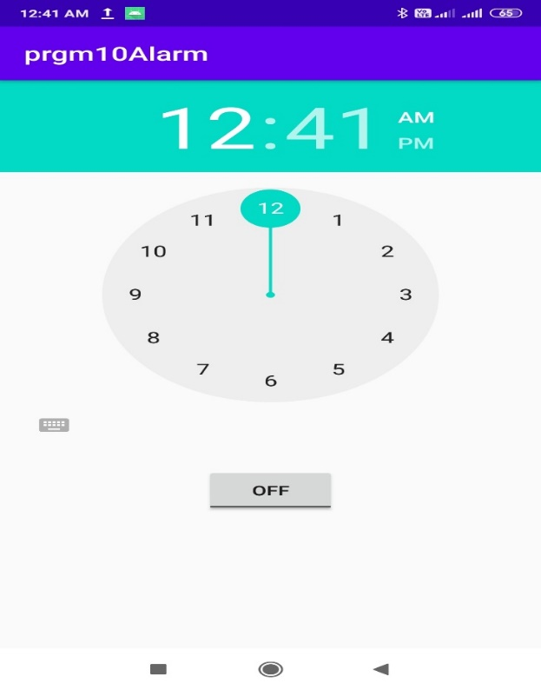

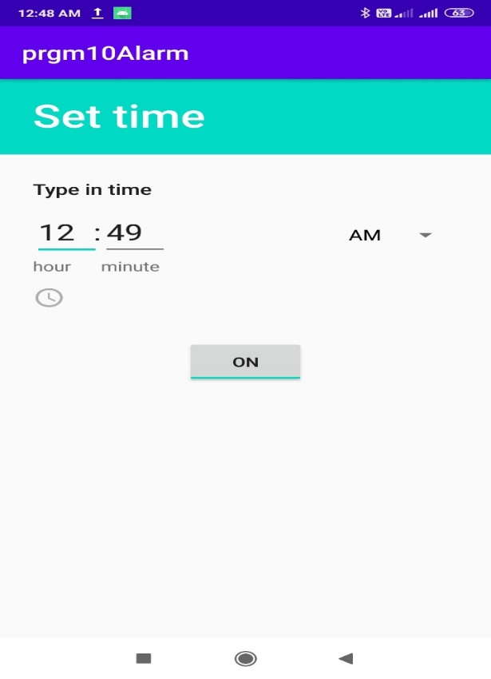

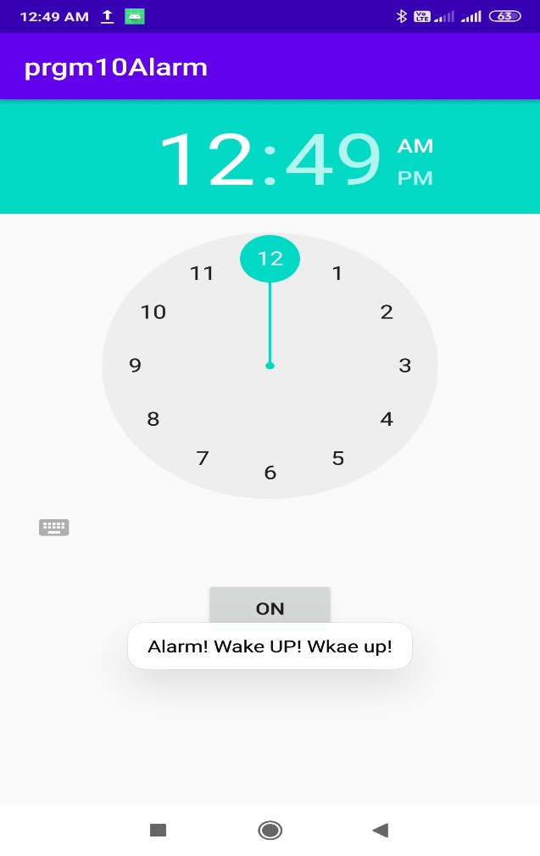

**11. Demonstrate the working GUI components. Font and Color.**

**activity_main.xml:**

*<?*xml version="1.0" encoding="utf-8"*?>*<LinearLayout xmlns:android="http://schemas.android.com/apk/res/android"  
 xmlns:app="http://schemas.android.com/apk/res-auto"  
 xmlns:tools="http://schemas.android.com/tools"  
 android:layout_width="match_parent"  
 android:layout_height="match_parent"  
 android:orientation="vertical"  
 android:layout_centerVertical="true"  
 tools:context=".MainActivity">  
  
 <TextView  
 android:id="@+id/textView"  
 android:layout_width="309dp"  
 android:layout_height="wrap_content"  
 android:layout_gravity="center"  
 android:layout_marginTop="200sp"  
 android:fontFamily="monospace"  
 android:gravity="center"  
 android:text="Please apply changes!"  
 android:textColor="#1F8A2D"  
 android:textSize="20sp"  
 android:textStyle="bold" />  
  
 <Button  
 android:id="@+id/button"  
 android:layout_width="match_parent"  
 android:layout_height="wrap_content"  
 android:layout_marginTop="50sp"  
 android:text="Change Font Size"  
 android:textSize="18sp" />  
  
 <Button  
 android:id="@+id/button2"  
 android:layout_width="match_parent"  
 android:layout_height="wrap_content"  
 android:layout_marginTop="20sp"  
 android:text="Change Font Color"  
 android:textSize="18sp" />  
</LinearLayout>

**MainActivity.java:**

package com.example.gui;  
  
import androidx.appcompat.app.AppCompatActivity;  
  
import android.graphics.Color;  
import android.os.Bundle;  
import android.view.View;  
import android.widget.Button;  
import android.widget.TextView;  
  
public class MainActivity extends AppCompatActivity {  
 int ch=1;  
 float font=30;  
 @Override  
 protected void onCreate(Bundle savedInstanceState) {  
 super.onCreate(savedInstanceState);  
 setContentView(R.layout.*activity_main*);  
 final TextView t=(TextView)findViewById(R.id.*textView*);  
 Button b1=(Button)findViewById(R.id.*button*);  
  
 b1.setOnClickListener(new View.OnClickListener()  
 {  
 @Override  
 public void onClick(View v)  
 {  
 t.setTextSize(font);  
 font=font+5;  
 if(font==50)  
 font=20;  
 }  
 });  
 Button b2=(Button)findViewById(R.id.*button2*);  
 b2.setOnClickListener(new View.OnClickListener() {  
 @Override  
 public void onClick(View v)  
 {  
 switch(ch)  
 {  
 case 1:  
 t.setTextColor(Color.*RED*);  
 break;  
 case 2:  
 t.setTextColor(Color.*BLUE*);  
 break;  
 case 3:  
 t.setTextColor(Color.*BLACK*);  
 break;  
 case 4:  
 t.setTextColor(Color.*GREEN*);  
 break;  
 case 5:  
 t.setTextColor(Color.*YELLOW*);  
 break;  
 }  
 ch++;  
 if(ch==5)  
 ch=1;  
 }  
 });  
  
 }  
}

**Output:**



